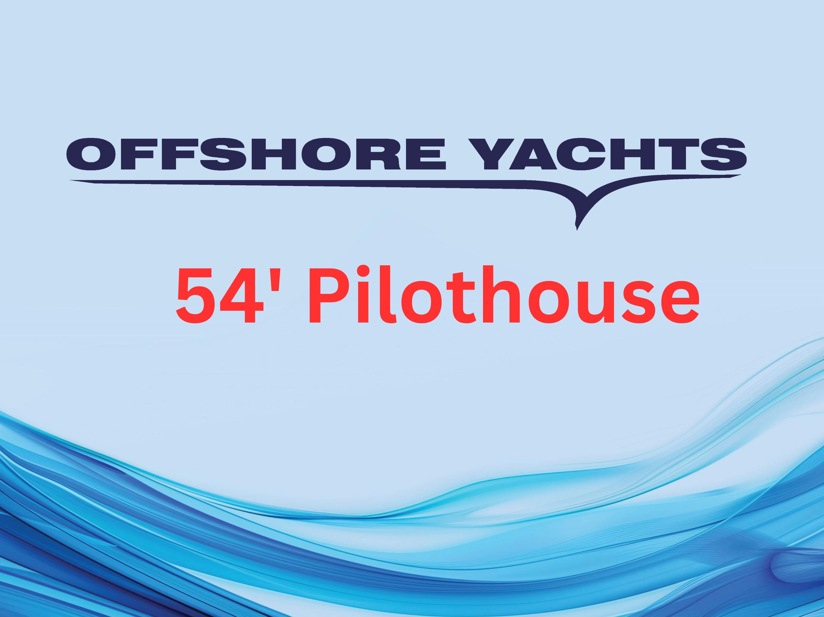

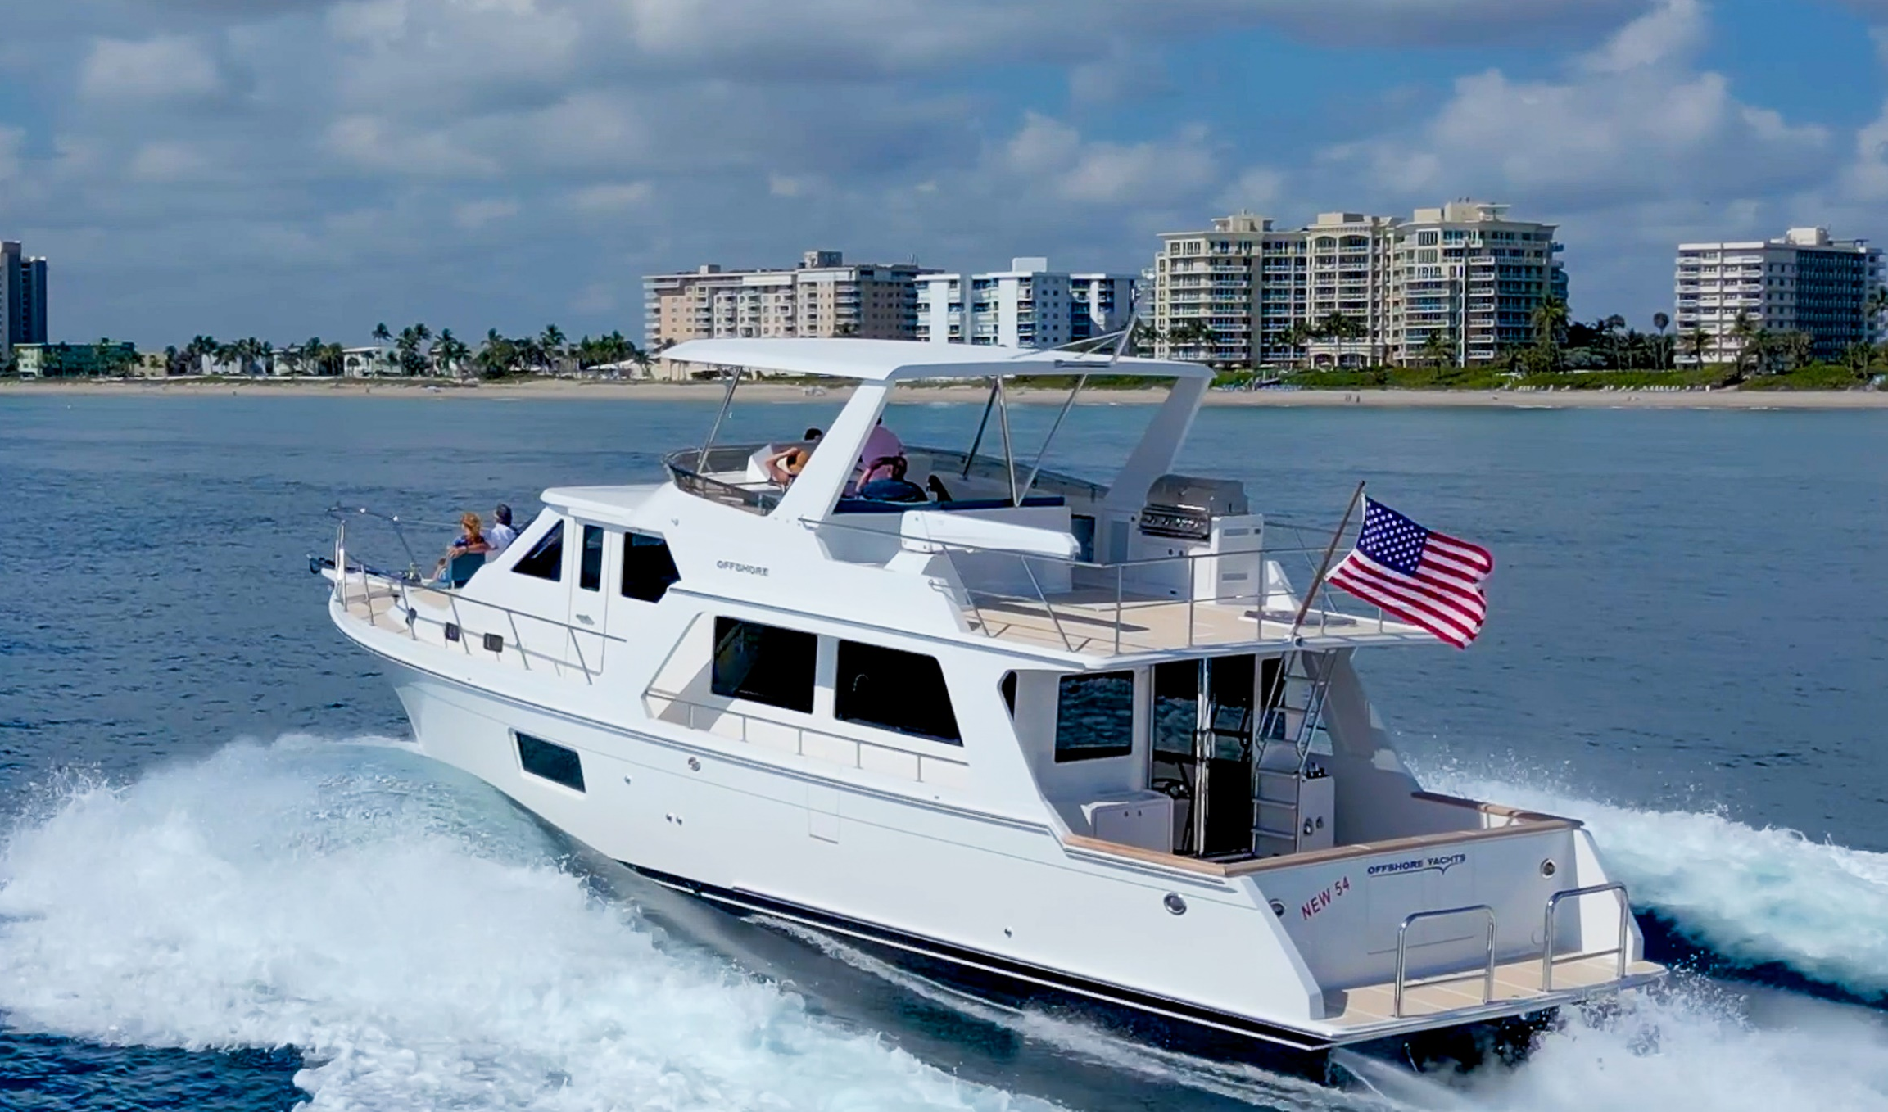

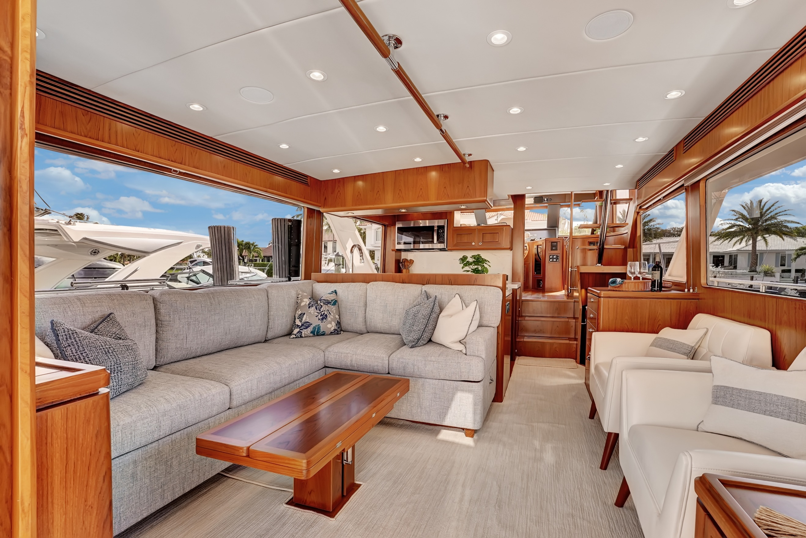

Offshore Legacy
Offshore Yachts has built a remarkable legacy and reputation over the past several decades, becoming a trusted name in the world of luxury cruising yachts. Founded on the principles of safety, comfort, and performance, Offshore Yachts has consistently delivered high quality, semi-custom coastal cruisers that are renowned for their exceptional seakeeping abilities and smooth ride.
One of the key factors contributing to Offshore Yachts’ enduring reputation is our commitment to continuous improvement and innovation. Each model undergoes thorough design reviews, ensuring that every yacht meets the highest standards of quality and functionality. Dedication to excellence has resulted in a loyal client base, with many owners returning for new builds.
Offshore Yachts’ designs, such as the Pilothouse and Voyager series, have become synonymous with elegance and reliability. Our yachts are not only visually stunning but also offer unparalleled comfort and safety, making them ideal for long-distance cruising.
Today, Offshore focuses on blending classic styling with modern amenities which allows us to cater to a sophisticated clientele who value tradition and functionality over fleeting trends.
In summary, Offshore Yachts’ legacy is built on a foundation of quality, innovation, and owner satisfaction. Offshore Yachts continue to be highly sought after, reflecting our company’s unwavering commitment to delivering the best cruising experience possible.

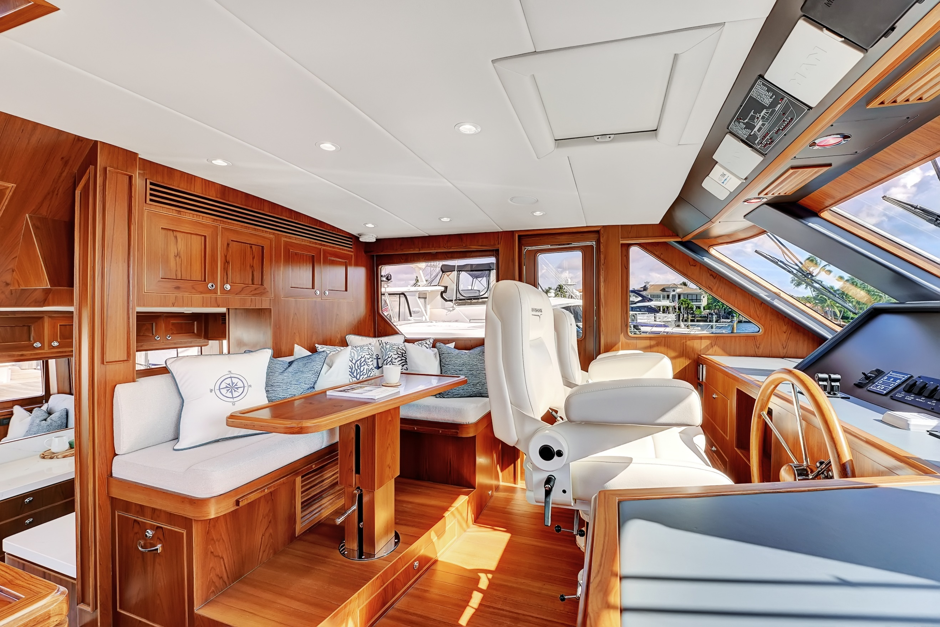

Design / Features / Equipment / Highlights
Offshore Yachts' commitment to blending classic design with modern elements
ensures that the 54 Pilothouse remains timeless while meeting the evolving needs
and preferences of today's sophisticated buyer.

Equipment
- SeaTorque enclosed shaft system, for quieter and smoother running, 5% to 8% fuel savings, and no cutless bearing maintenance.
- Optimus electric steering system
- Termodinamica A/C and Heat – minimal amp draw system is incredibly quiet and efficient.
- ZF JMS (joystick maneuvering system)
- Mastervolt Energy Control System. Less generator time, less fuel, and likely no replacement of batteries with up to 3500 full cycles before replacement.
- Sleipner/Side Power all speed hydraulic stabilizers, bow and stern thruster system.

Galley
- Full slab Quartz or granite countertops with honeycomb for weight savings
- Custom utensil drawer with Henckel cutlery and knives.
- Full size Fisher Paykel refrigerator/freezer & ice maker
- Undercounter Bosch speed oven/microwave leaving more open space to the pilothouse
- Stylish stainless steel apron front sink
- Super open concept and light filled galley

Salon

- TV lift for 43” LED in port aft corner provides best viewing angle for all guests in salon
- Substantial increase in space on starboard side allowing for two comfortable occasional chairs (included) due to the new TV lift location.
- Custom upholstered sofa décor pillows for homestyle furniture comfort and look.
- Custom Roman shades at main deck and owner’s suite windows
- New port and starboard elongated windows for maximum light and views
- Updated and modernized joinery work on all cabinet tops.
- New mirror polished stainless steel framed doors, full height, providing maximum light and views aft.
- New SS and teak overhead handrail
- More efficient and quieter decorative grills for air conditioning and heat distribution.

Pilothouse

- Dual Stidd helm chairs with Ultraleather upholstery
- Stainless steel and leather handrails on open concept floating stairs to flybridge
- New three large view windows for even better visibility at forward pilothouse
- Custom upholstered settee and décor pillows
- New overhead storage cabinets and access above settee
- New custom Ultraleather upholstered helm counter and baseball stitched equipment console
- New design full port to starboard overhead instrument panel

Master Stateroom
- Large hullside view window
- Custom painted and paneled shiplap wall and decorative columns behind berth with integrated sconces
- Quartz countertops on nightstands.
- Two nightstands with storage drawers in each
- 43” LED TV
- More efficient and quieter decorative grills for air conditioning and heat distribution.
- Cupola style escape hatch for additional light into the cabin
- Light and Bright

Cockpit

- Double centerline transom doors – to open your view to the water while inside the salon or enjoying the cockpit
- Recessed door lock handle for transom doors
- Heavy duty, recessed hawse holes with cleats
- Stainless steel handrail on underside of lazarette hatch for safe entry
- Electric lazarette hatch lift
- More headroom in lazarette

Flybridge and Boat deck

- Fiberglass hard top with overhead lighting and speaker system
- Newly designed wider and lower profile molded fiberglass instrument console
- Dual Stidd helm chairs with Ultraleather upholstery
- Steelhead 1000 lb. davit
- Blaze Marine 316 stainless steel BBQ grill
- Space for 13’ tender
- Interior and aft access to flybridge

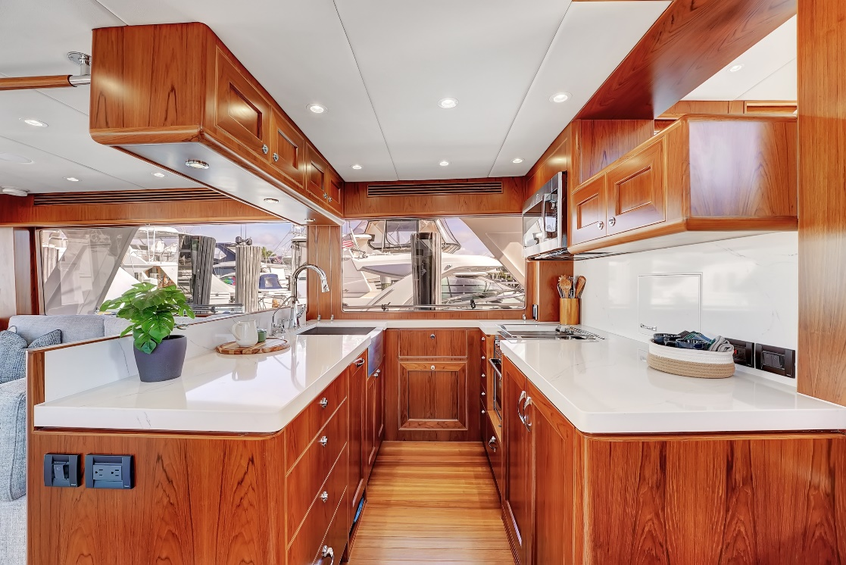

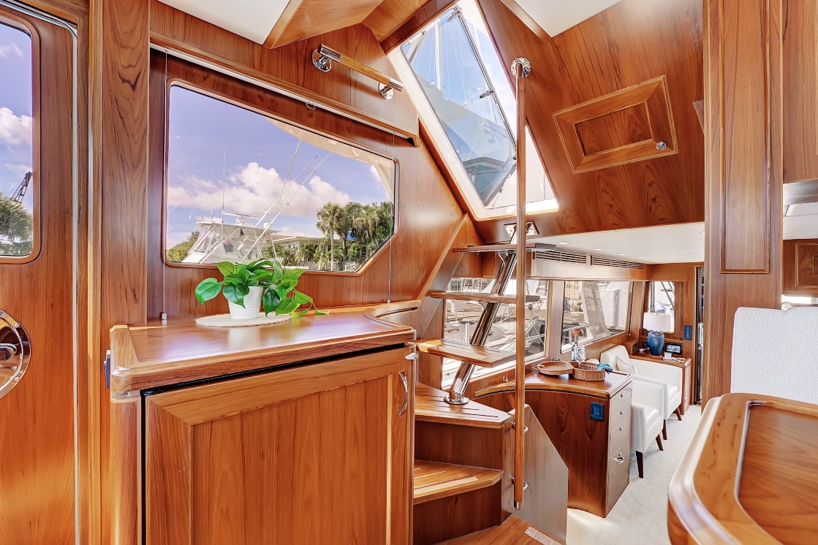
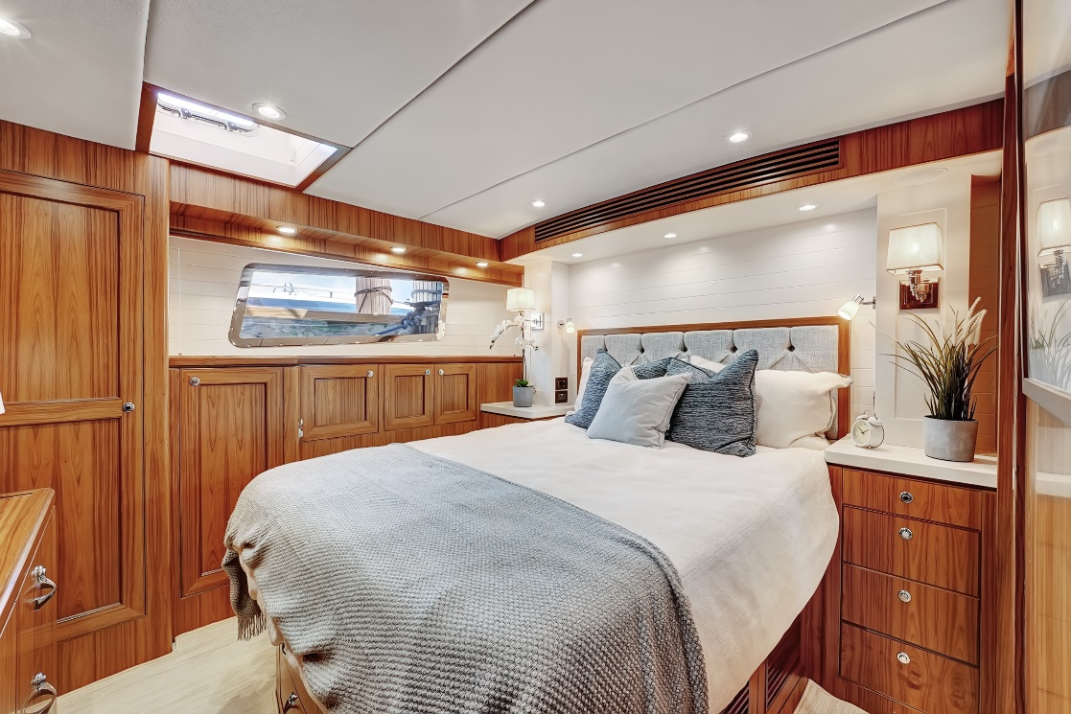

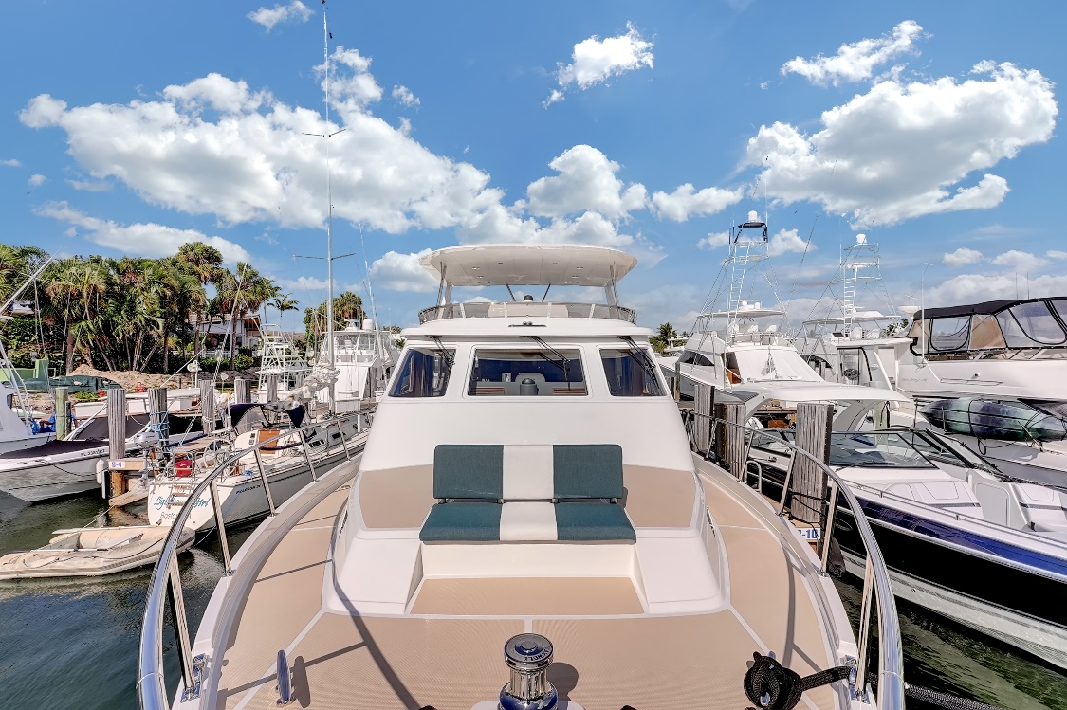

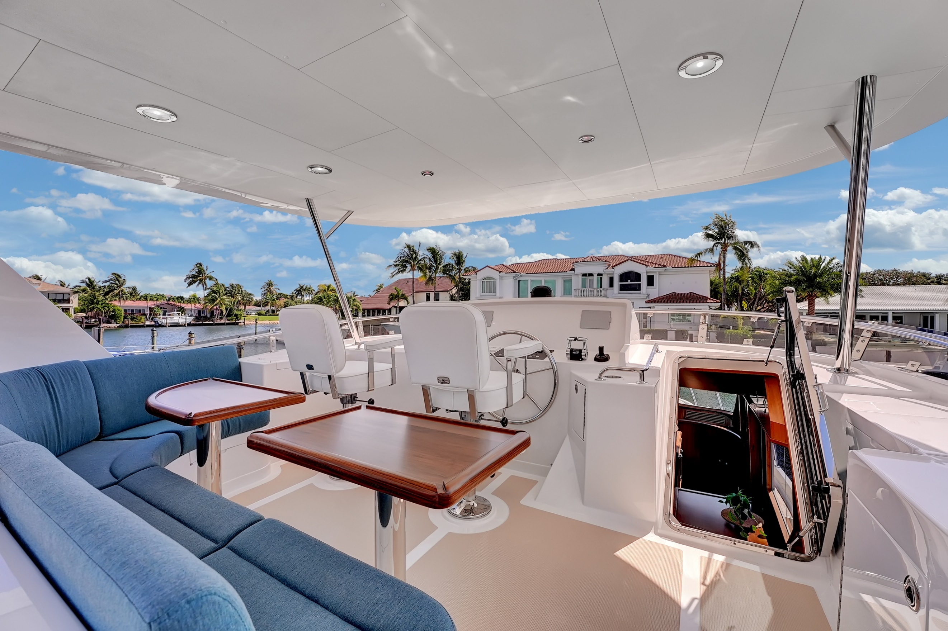

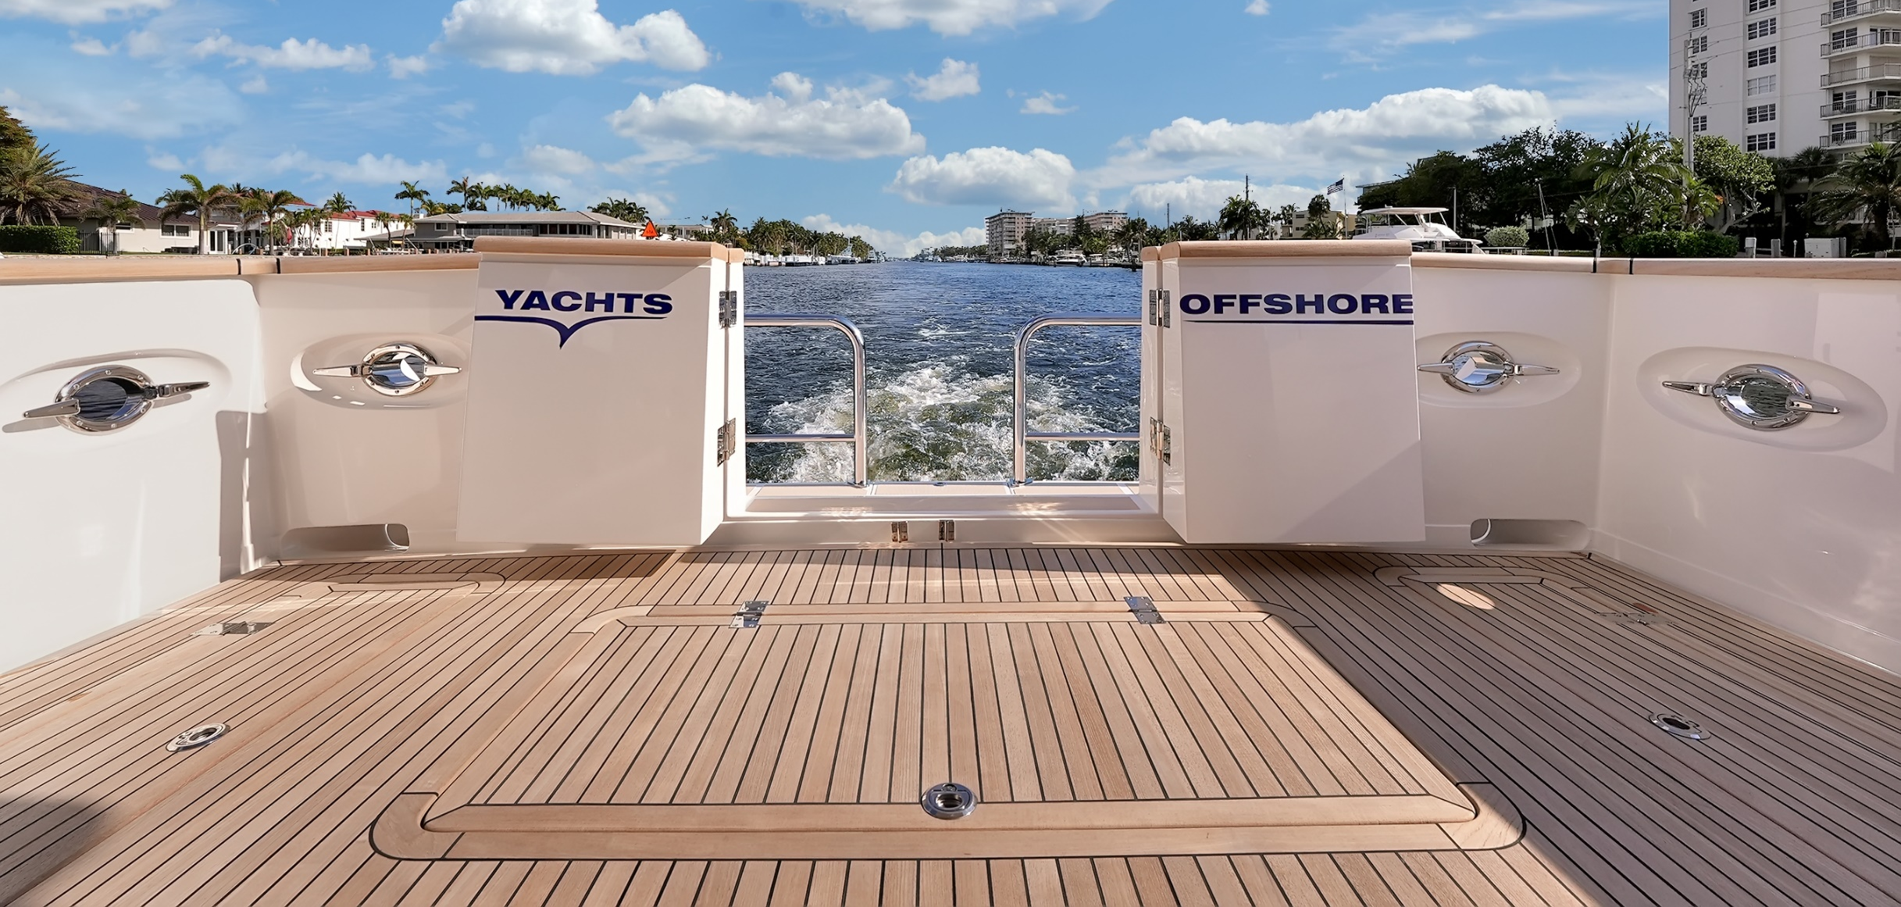

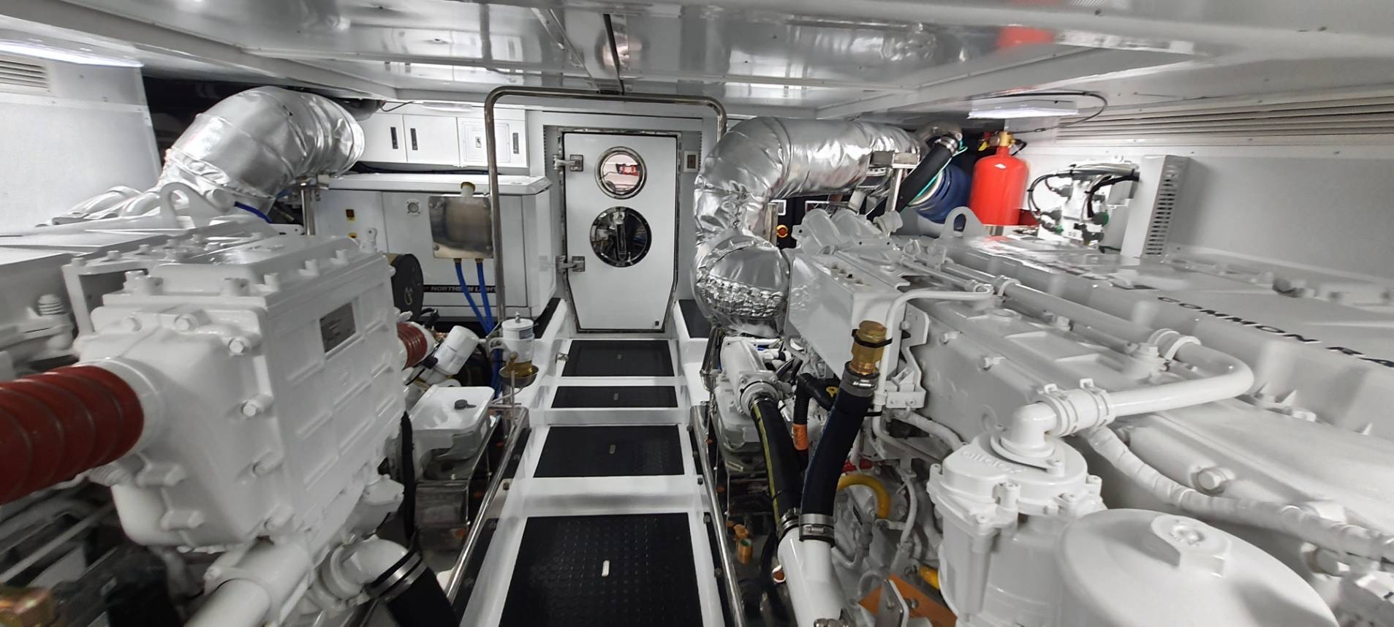

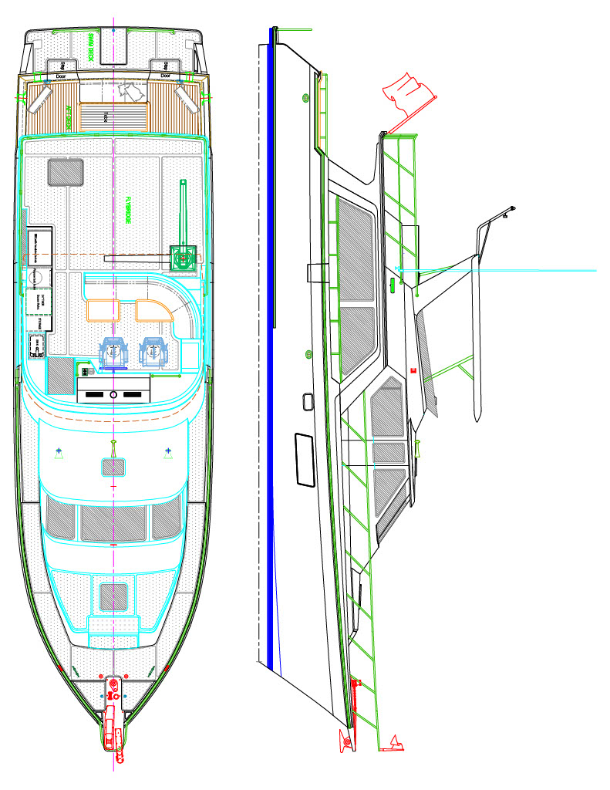
Offshore 54 Pilothouse – Profile and Flybridge

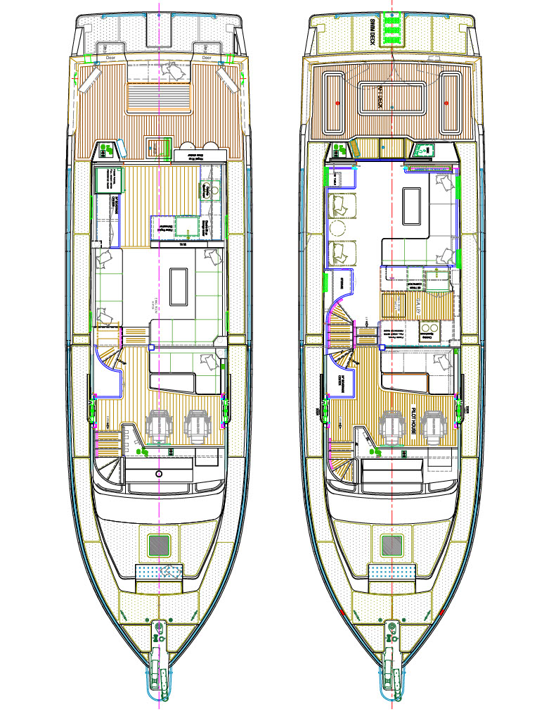
Main Deck - Midship or Aft Galley, cockpit table or double doors

